**Ideation Phase**

**Empathize & Discover**

|  |  |
| --- | --- |
| Date | 05 July 2025 |
| Team ID | LTVIP2025TMID35592 |
| Project Name | EduTutor AI: Personalized Learning With Generative AI And LMS Integration |
| Maximum Marks | 4 Marks |

**🧠 Empathy Map Canvas: Edututor Ai – Personalized Learning with Generative AI and LMS Integration**

* **Thinks: “How can we personalize learning for every student without burning out educators?”**
* **Sees: AI-generated lessons, quizzes, and adaptive dashboards transforming the learning experience.**
* **Says: “Edututor Ai just tailored the curriculum to each learner—this changes everything.”**
* **Hears: Encouraging feedback from students, insights from the AI, and LMS notifications with progress flags.**
* **Feels: More supported, confident, and in control of teaching and learning outcomes.**
* **Pains: Resistance to new tech, time to train staff, integration concerns with existing LMS platforms.**
* **Gains: Personalized learning at scale, increased learner engagement, and real-time insight into progress.**

**Example:**

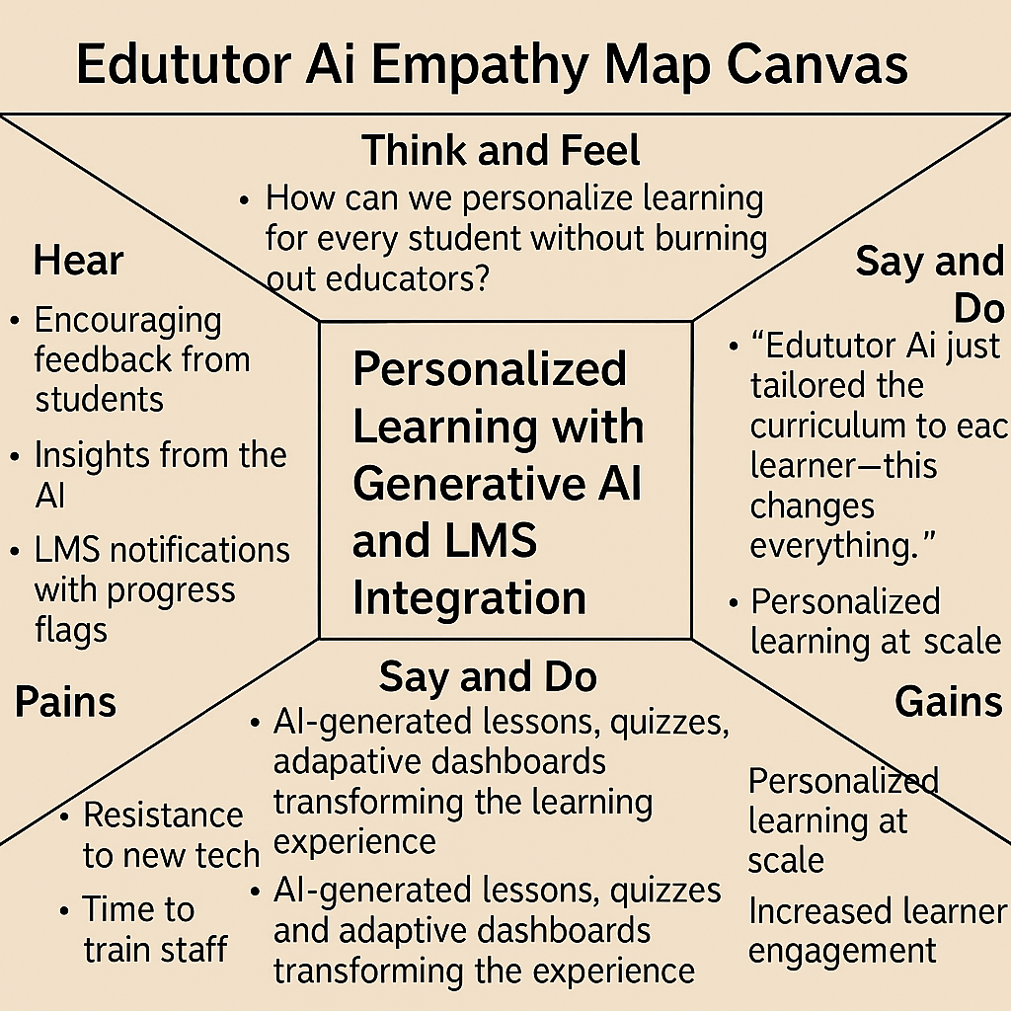

Reference: <https://www.nngroup.com/articles/empathy-mapping>

**Example: 📌 Edututor Ai – Personalized Learning with Generative AI and LMS Integration (Short Notes)**

* **Context: High school classroom with mixed-ability learners**
* **Challenge: Hard to personalize content; teachers overwhelmed by manual grading and content prep**
* **Platform: Edututor Ai + LMS (e.g., Moodle)**

**✅ AI-Driven Features:**

* **Learner profiling based on past performance, behavior, and preferences**
* **Auto-generated personalized content (quizzes, lessons, visual aids)**
* **Real-time content adaptation based on student interaction**
* **Integrated with LMS for seamless delivery**
* **Instructor dashboard with insights and grading automation**
* **Weekly AI-generated parent updates**

**🎯 Results:**

* **30% rise in engagement**
* **Faster learning among low-performing students**
* **Teachers saved 5+ hours/week on repetitive tasks**

